Use Case Changes

1. Added a Credit Bureau as an actor for Pre-Flight/Main Use Cases to check and make sure that the customer has a good financial background.
2. Added Agent Log-In to Main
3. Added Search Flights to Main to <<include>> Calculate Costs
4. Added Provide Met Watch Scenarios to Main to <<include>> Search Flights
5. Added Add Credit to Customer Profile to Preflight to <<extend>> Create Customer via a manager
6. Added Cancel Watch to Flight Reservation to <<extend>> Reserve Flights

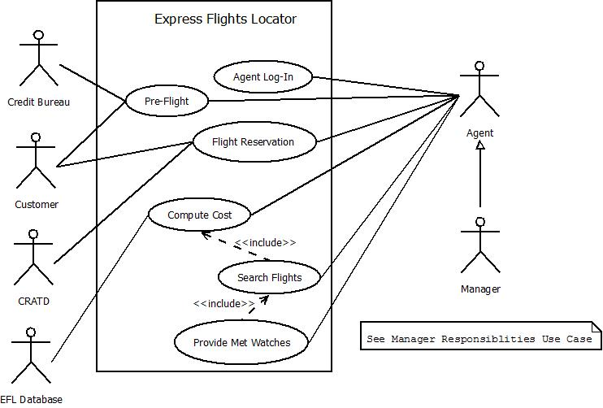

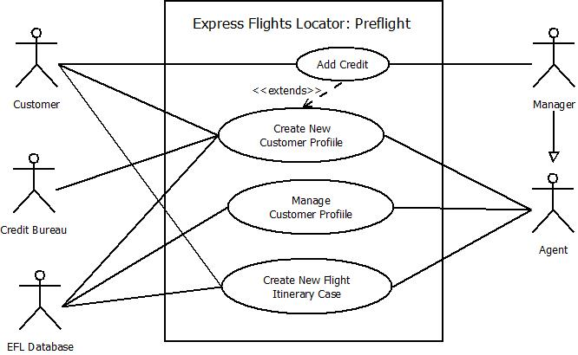

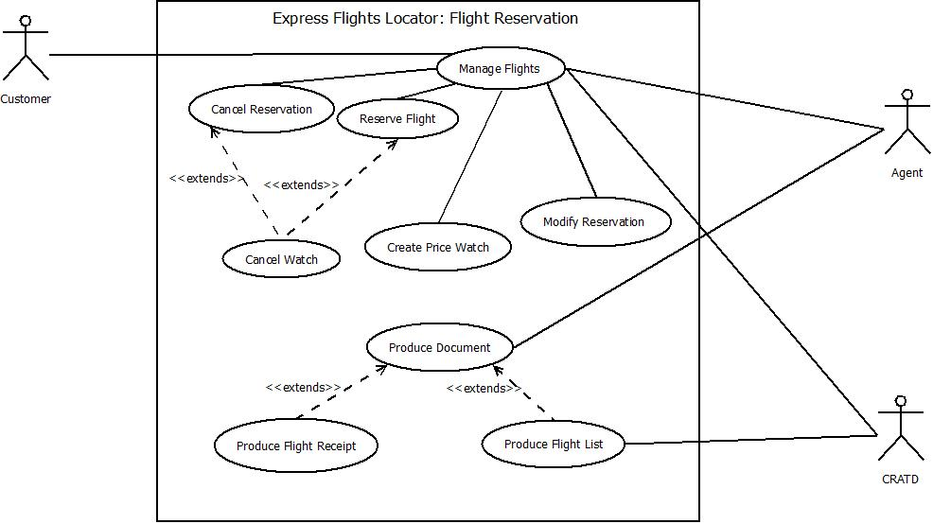

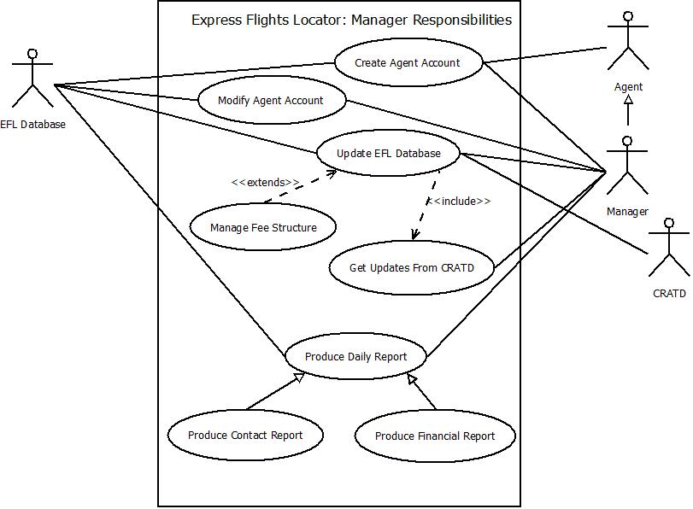

Use Case Description Changes

1. Use Case Description: Create New Customer Profile Change: Customer accepts services
2. Use Case Description: Create New Customer Profile Change: Customer denies services
3. Use Case Description: Create New Customer Profile Change: Customer’s credit is bad

The Following Are Brand New Use Cases

1. Use Case Description: Agent Log-In

2. Use Case Description: Search Flights

3. Use Case Description: Provide Met Watch Scenarios

4. Use Case Description: Add Credit to Customer Profile

5. Use Case Description: Cancel Watch

|  |  |
| --- | --- |
| **Use Case Name:** | Create New Customer Profile |
| Related Requirements |  |
| Goal in Context | Successfully create a customer profile |
| Preconditions | 1. Customer wants to book a flight (calls or comes in person)  2. Customer has:  A Name  An Address of Residency  A Phone Number  3. Customer has a credit card |
| Successful End Condition | The new customer profile is created and stored |
| Failed End Condition | The customer profile is not successfully created or stored |
| Primary Actor(s) | Customer  Agent |
| Secondary Actor(s) |  |
| Trigger | Customer calls or enters Cougar Path Travel |

|  |  |  |
| --- | --- | --- |
| **Main Flow** | **Step** | **Action** |
|  | 1 | New Customer calls or enters Cougar Path Travel |
|  | 2 | Agent explains fee structure |
|  | 3 | Customer decides to accept or deny services |
|  | 4 | Customer provides personal information and credit information |
|  | 5 | Agent verifies credit information |
|  | 6 | Agent saves Customer Profile |
|  |  |  |
|  |  |  |
|  |  |  |
|  |  |  |
| **Extensions** | **Step** | **Branching Action** |
|  | 3.A.1 | Customer accepts services |
|  | 3.A.2 | Go to Step 4 |
|  | 3.B.1 | Customer denies services |
|  | 3.B.2 | No further Steps taken |
|  | 5.A.1 | Customer’s credit information is valid and their credit is good |
|  | 5.A.2 | Go to Step 6 |
|  | 5.B.1 | Customer’s credit information is invalid, their credit is bad, or both of these conditions are met |
|  |  |  |

|  |  |
| --- | --- |
| **Use Case Name:** | Agent Log-In |
| Related Requirements |  |
| Goal in Context | Agent will log into the system using their Agent ID number and password |
| Preconditions | Agent must have an existent Agent Profile |
| Successful End Condition | Agent successfully logs into the system |
| Failed End Condition | Agent fails to log into the system |
| Primary Actor(s) | Agent |
| Secondary Actor(s) |  |
| Trigger | Agent wishes to use the system |

|  |  |  |
| --- | --- | --- |
| **Main Flow** | **Step** | **Action** |
|  | 1 | Agent attempts to log into the system by entering their employee ID and password |
|  | 2 | Verify log-in information |
|  | 3 | Log-in complete |
|  |  |  |
|  |  |  |
|  |  |  |
|  |  |  |
|  |  |  |
|  |  |  |
|  |  |  |
| **Extensions** | **Step** | **Branching Action** |
|  | 2.A.1 | Log-in information is correct |
|  | 2.A.2 | Go to Step 3 |
|  | 2.B.1 | Log-in information is incorrect |
|  | 2.B.2 | No further Steps taken |
|  |  |  |
|  |  |  |
|  |  |  |
|  |  |  |

|  |  |
| --- | --- |
| **Use Case Name:** | Search Flights |
| Related Requirements |  |
| Goal in Context | Search for a flight and compute its corresponding cost |
| Preconditions | The customer must have a corresponding Itinerary |
| Successful End Condition | Flight search and flight cost computation were successfully completed |
| Failed End Condition | Flight search failed to be completed, flight cost failed to be calculated, or a combination of the aforementioned conditions |
| Primary Actor(s) | Agent |
| Secondary Actor(s) | EFL Database |
| Trigger | Agent decides to look up flights |

|  |  |  |
| --- | --- | --- |
| **Main Flow** | **Step** | **Action** |
|  | 1 | Agent sets up a search for a flight |
|  | 2 | Agent computes cost of the found flight (See Compute Cost) |
|  |  |  |
|  |  |  |
|  |  |  |
|  |  |  |
|  |  |  |
|  |  |  |
|  |  |  |
|  |  |  |
| **Extensions** | **Step** | **Branching Action** |
|  | 1.A.1 | Flight found |
|  | 1.A.2 | Go to Step 2 |
|  | 1.B.1 | Flight not found |
|  | 1.B.2 | No further Steps taken |
|  |  |  |

|  |  |
| --- | --- |
| **Use Case Name:** | Provide Met Watch Scenarios |
| Related Requirements |  |
| Goal in Context | Provide any met watches to an Agent |
| Preconditions | At least one Price Watch must have been made by a Customer |
| Successful End Condition | Successfully provided an Agent with met watch scenarios |
| Failed End Condition | Failed to provide an Agent with met watch scenarios |
| Primary Actor(s) | Agent |
| Secondary Actor(s) | EFL Database |
| Trigger | Agent checks to see if any Price Watches have been met |

|  |  |  |
| --- | --- | --- |
| **Main Flow** | **Step** | **Action** |
|  | 1 | Agent requests all met Price Watch Scenarios to be listed |
|  | 2 | Search Flights for met Price Watches |
|  | 3 | All met Price Watches are returned and listed for the Agent |
|  |  |  |
|  |  |  |
|  |  |  |
|  |  |  |
|  |  |  |
|  |  |  |
|  |  |  |
| **Extensions** | **Step** | **Branching Action** |
|  |  |  |

|  |  |
| --- | --- |
| **Use Case Name:** | Add Credit to Customer Account |
| Related Requirements |  |
| Goal in Context | Add Credit to a newly created Customer profile |
| Preconditions | Customer was referred by an existing Customer  Customer has just created a Customer Profile |
| Successful End Condition | Credit is added to the Customer’s Profile |
| Failed End Condition | Credit is not added to the Customer’s Profile |
| Primary Actor(s) | Customer  Agent |
| Secondary Actor(s) |  |
| Trigger | A new Customer tells an Agent they were referred by an existing Customer |

|  |  |  |
| --- | --- | --- |
| **Main Flow** | **Step** | **Action** |
|  | 1 | Agent asks Customer if they were referred by an existing Customer |
|  | 2 | Customer responds |
|  | 3 | Credit is added to referring Customer’s existing Customer Profile |
|  |  |  |
|  |  |  |

|  |  |
| --- | --- |
| **Use Case Name:** | Cancel Watch |
| Related Requirements |  |
| Goal in Context | Cancel a Price Watch |
| Preconditions | The customer has created an Itinerary  A Price Watch must have been created |
| Successful End Condition | The correct Price Watch has been successfully cancelled. |
| Failed End Condition | The correct Price Watch has not been successfully cancelled. |
| Primary Actor(s) | Customer  Agent |
| Secondary Actor(s) | EFL Database |
| Trigger | A customer wishes to cancel a Price Watch  OR  A Price Watch expires |

|  |  |  |
| --- | --- | --- |
| **Main Flow** | **Step** | **Action** |
|  | 1 | Price watch cancellation initiated |
|  | 2 | Agent cancels Price Watch |
|  |  |  |
|  |  |  |
|  |  |  |
|  |  |  |
|  |  |  |
|  |  |  |
|  |  |  |
|  |  |  |
| **Extensions** | **Step** | **Branching Action** |
|  | 1.A.1 | Customer requests to cancel a Price Watch on a current Flight |
|  | 1.A.2 | Go to Step 2 |
|  | 1.B.1 | Price Watch expires (has existed for 30 days) |
|  | 1.B.2 | Go to Step 2 |